SSSNP Rebuild Procedure
Frontends (ASU APP)

- Install IIS as in the below screenshots:
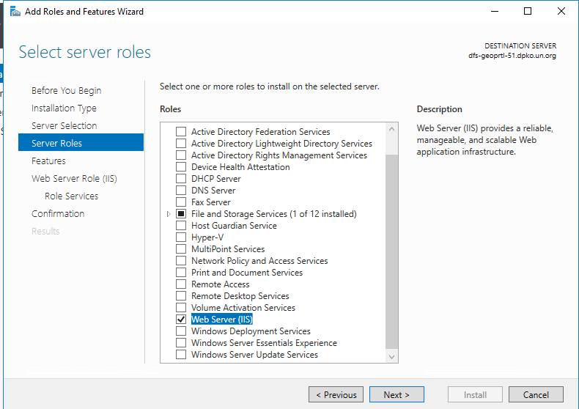
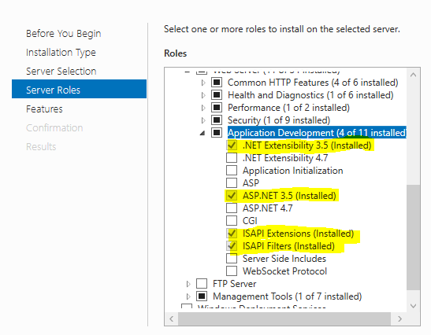

- Add dpko\_SSSNP_Green user to the list of administrators
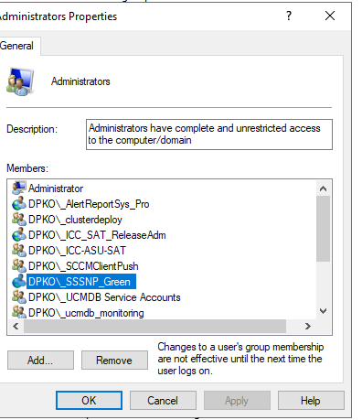
- Delete default web site and drop all application pools
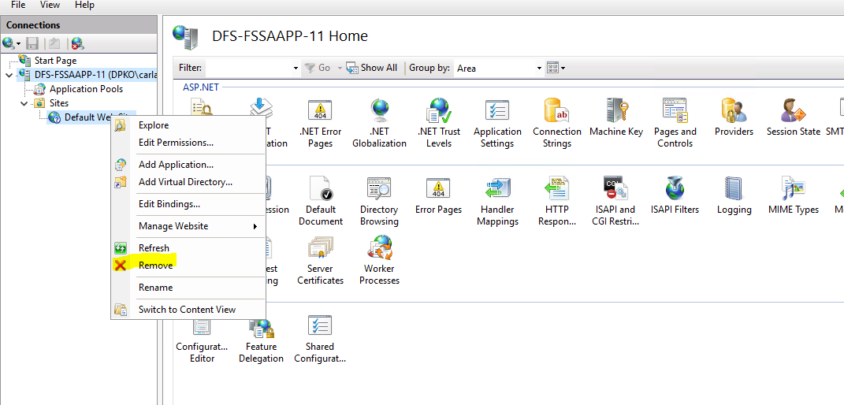

- CREATE new Application Pool: www.snsdpmis.com
Application Pool identity dpko\_SSSNP_Green (password saved in keepass)
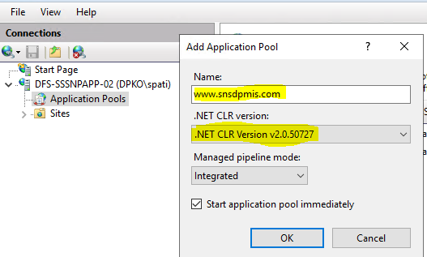
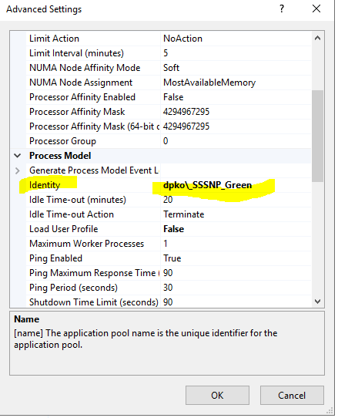
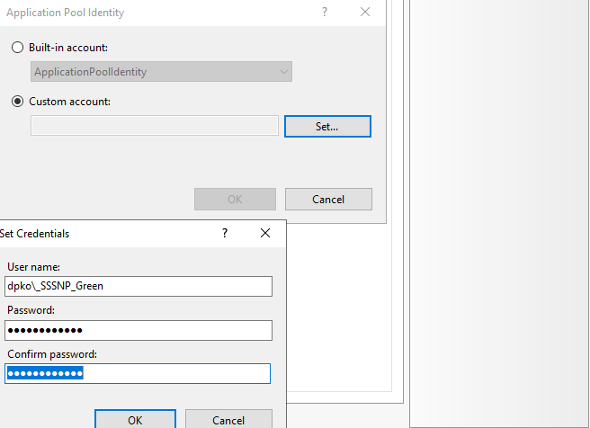

- CREATE new Website: www.snsdpmis.com
Connect as specific user dpko\_SSSNP_Green (password saved in keepass)
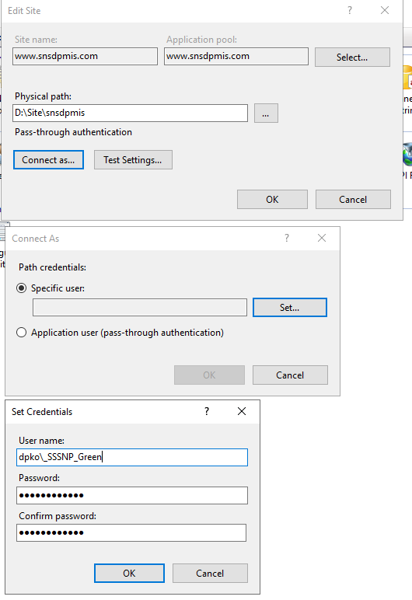

- Give to dpko\_SSSNP_Green user full control permission of website folder D:\Site\snsdpmis
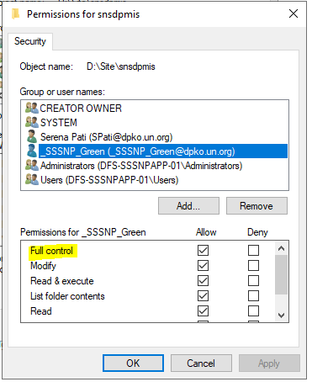
- Update connection string on web.config.
Password for user _sssnpgreenuser is saved on Keypass

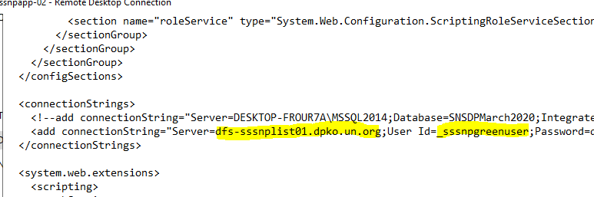

- Final output should be:
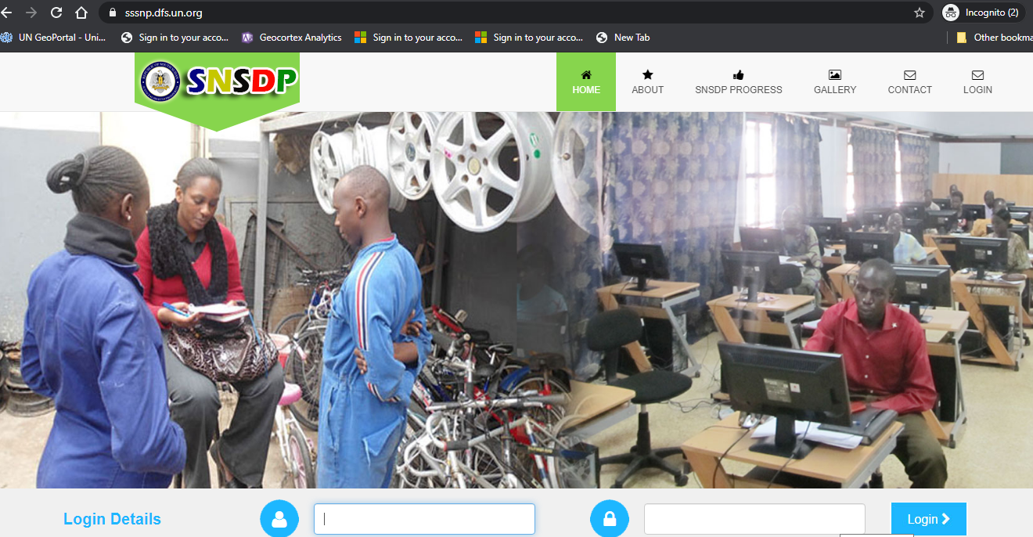

- Apply DFS Replication for the below folders. Please refer to SSSNP DFSR.docx document
  - Alternateone
  - Alternatetwo
  - Photo
  - MOA
  - WageFile

- Create tasks. Please refer to API Scheduler Document.docx document

- Grant execute permission to the DB user
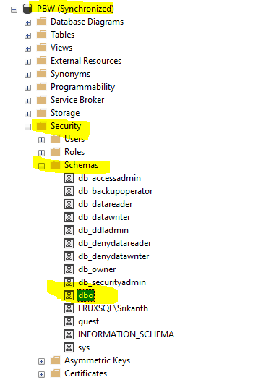
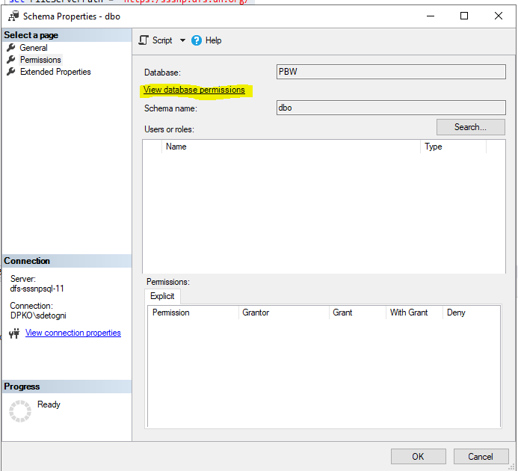
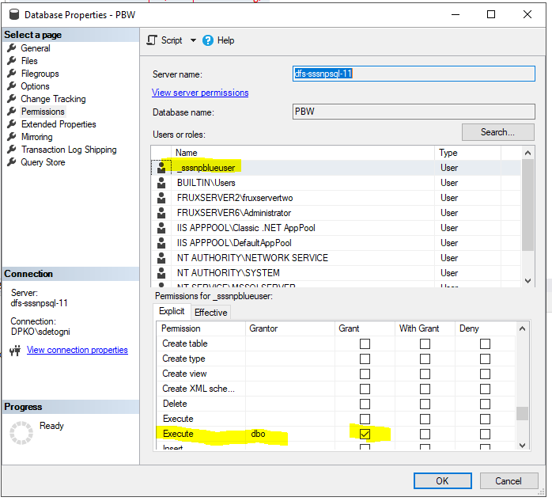
Or with script
use [PBW]
GO
GRANT EXECUTE TO [_sssnpgreenuser]
GO

- File path where replicated folders (DFSR folders) are stored is defined in following table inside the DB. This value should be updated with the application URL
Execute scripts contained on folder “Update File Paths”

To fix issue on security assessment and deny to access to the nodes directly
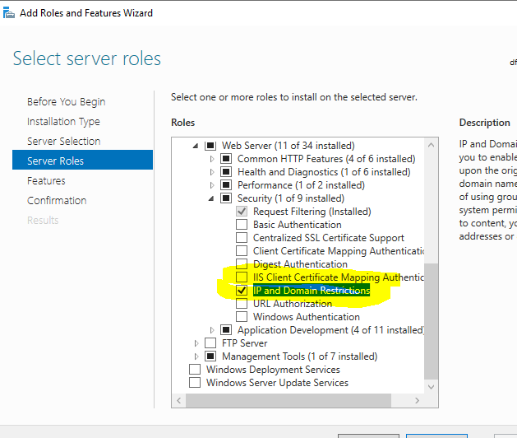
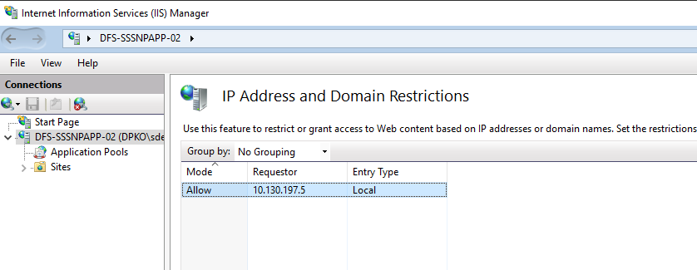
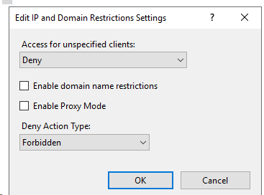
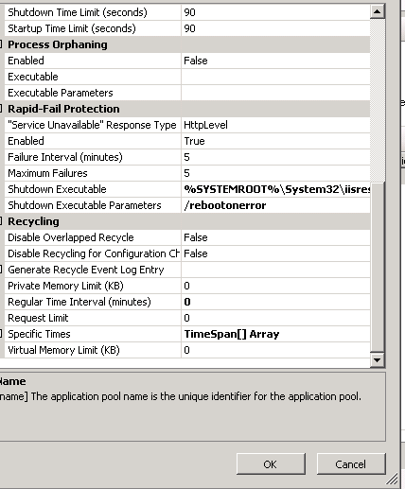

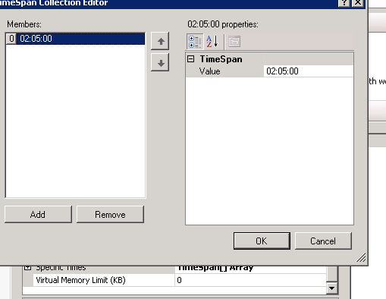
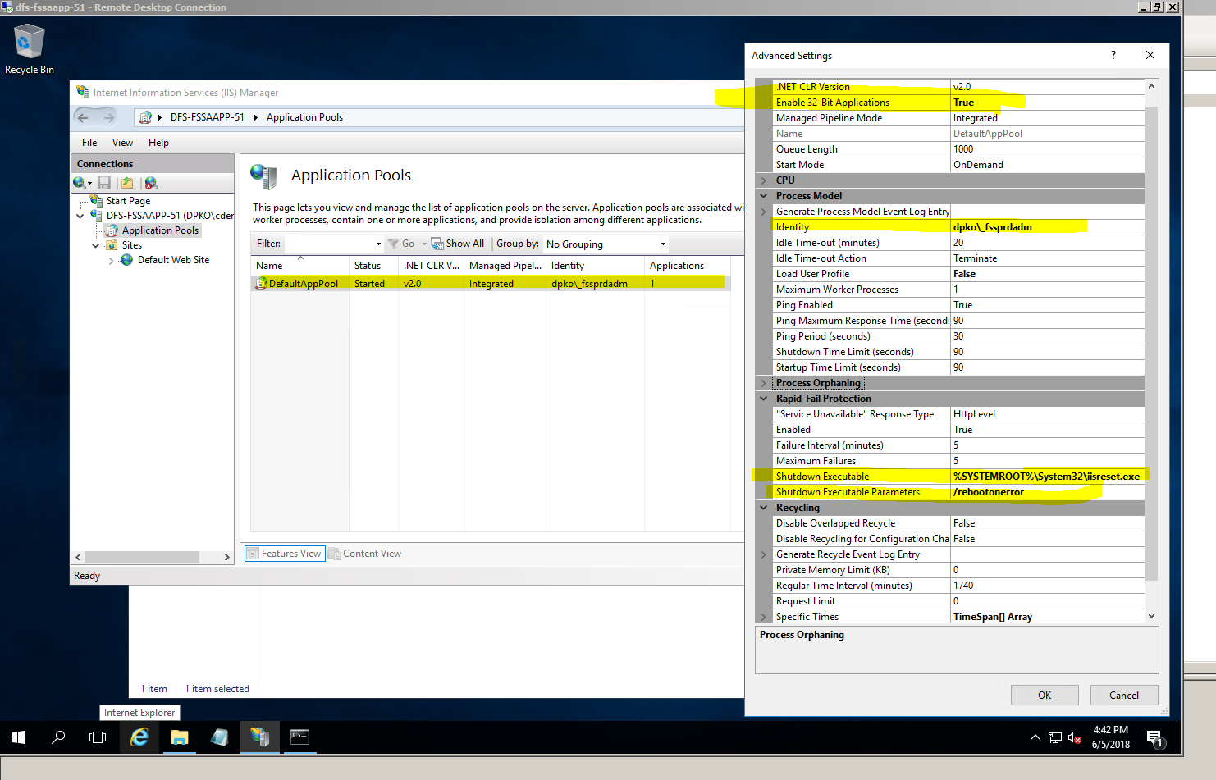
Copy-paste the below command into the shutdown executable:
%SYSTEMROOT%\System32\iisreset.exe
Copy-paste the below command into the shutdown executable parameters”
/rebootonerror

Install of Microsoft Report viewer
\\dfs-asufs-01\Software\Microsoft\ReportViewer2010

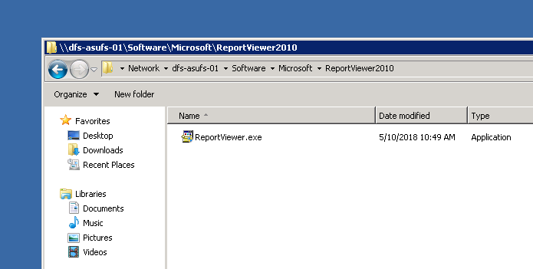
- Installation of Microsoft access database engine (to be installed the 32 bit version)
\\dfs-asufs-01\Software\Microsoft\Access Database Engine 2010
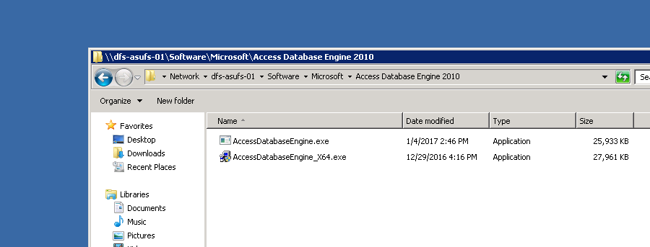
- ASPNET MVC installation AspNetMVC2_VS2008.exe
Install the AspNetMVC2_VS2008.exe from the below source path
\\dfs-asufs-01\Software\Microsoft\ASP_NET_MVC_4
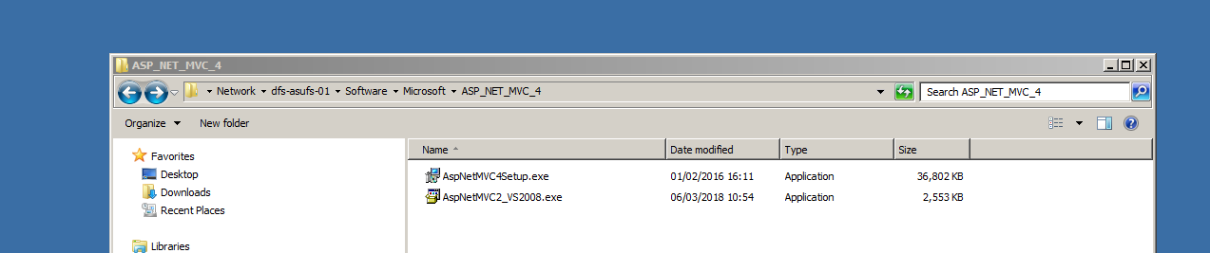

- Install Topaz from:
\\dfs-asufs-01\Software\Topaz
Selecting the below options

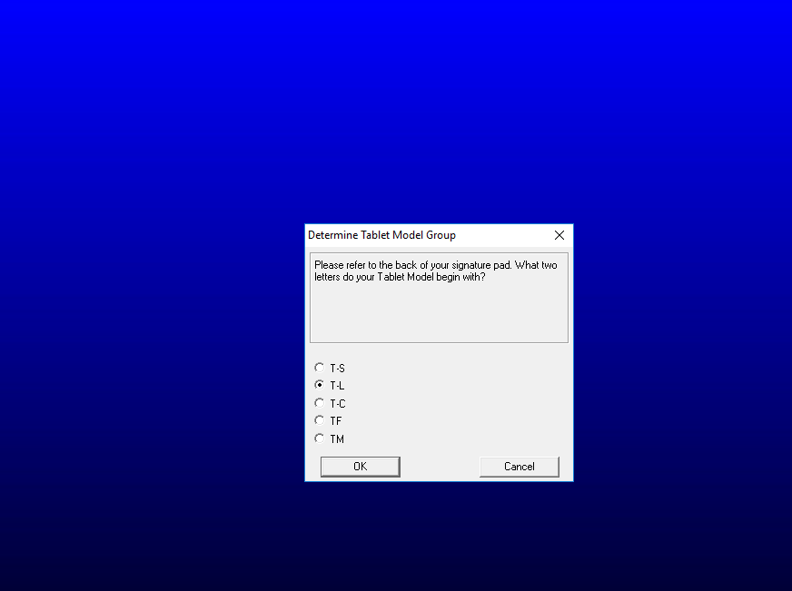
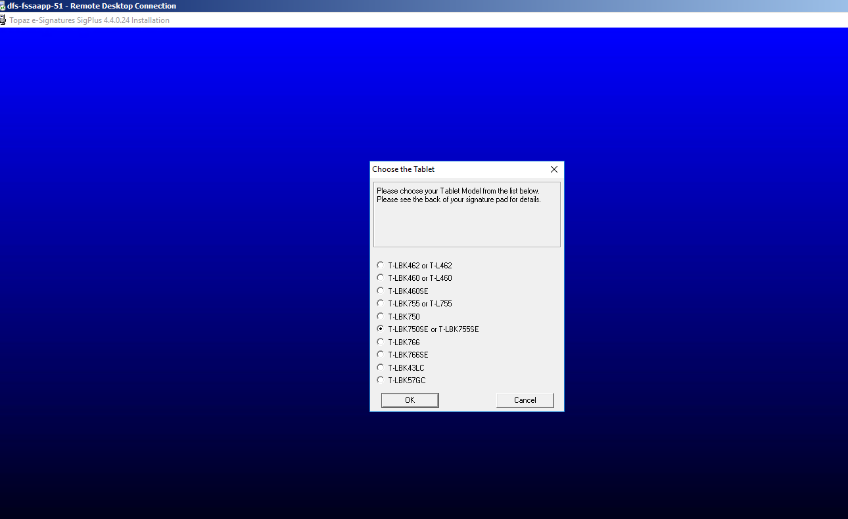

- Check that windows PowerShell v4 or later is installed
Open a windows PowerShell and execute the below command:
$PSVersionTable
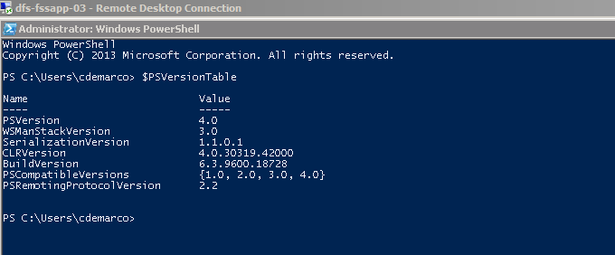
If needed install the windows management pack from the below path
\\dfs-asufs-01\Software\Microsoft\WindowsManagementPack
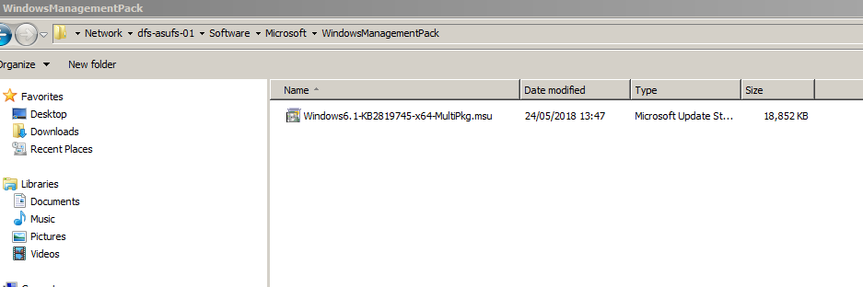

- Install the below font
copy-paste the font found in the below path
\\dfs-asufs-01\Temp\FSS_FONT
Into the local server folder c:\windows\fonts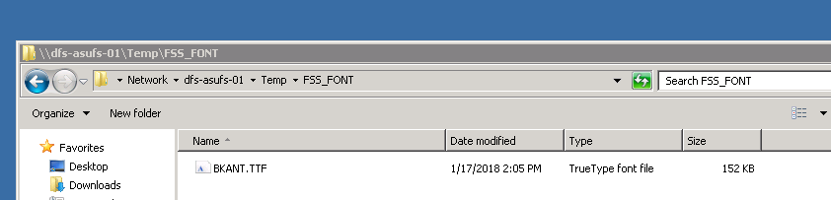

- Create new web site (i.e. Default Web Site)
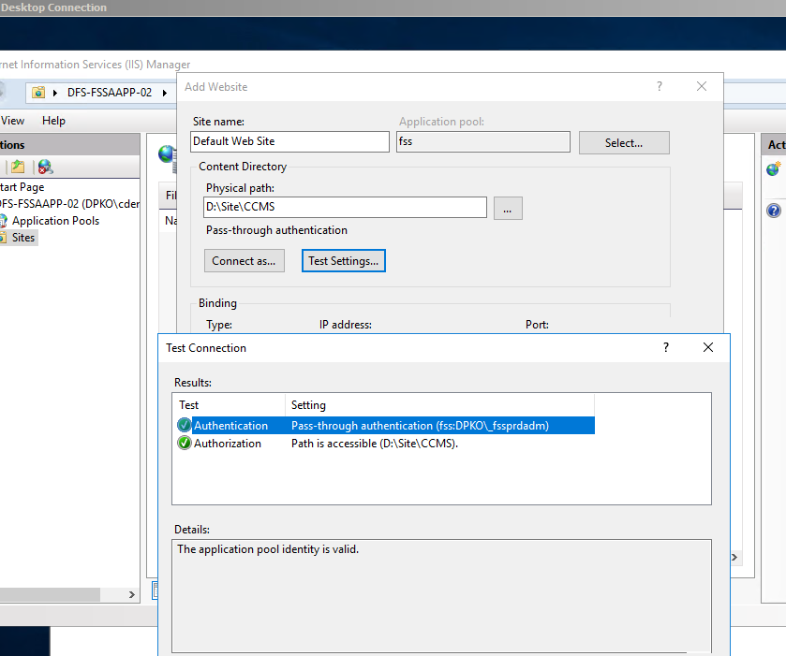
- NOT NEEDED ANYMORE: SET TO THE BELOW FOLDERS FULL CONTROL TO IIS_IUSRS USER (search also excel and access keywords)
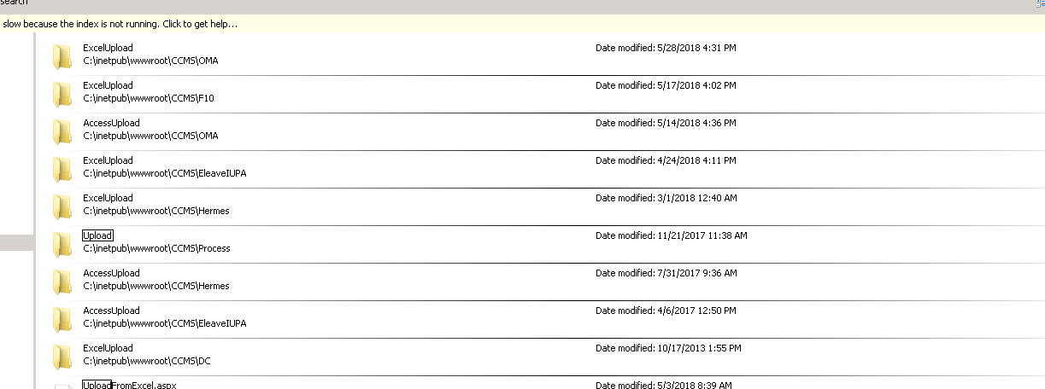
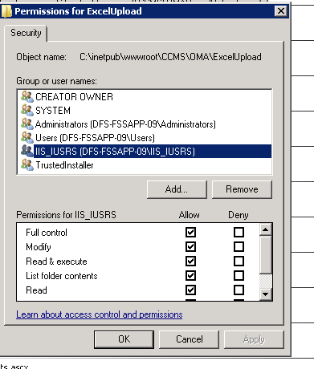

- Install the code-signing FSS OFFLINE FORM certificate:
- Copy the renewed certificate from (\\dfs-asufs-01\Temp\FSS_OF) into the IIS server
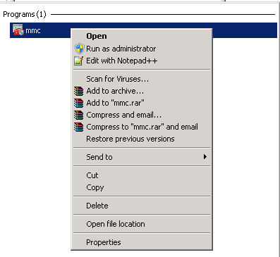
- Import the certificate:
  - Run mmc as Administrator
  - Go to File – Add/Remove Snapins… - Certificates for Local Computer
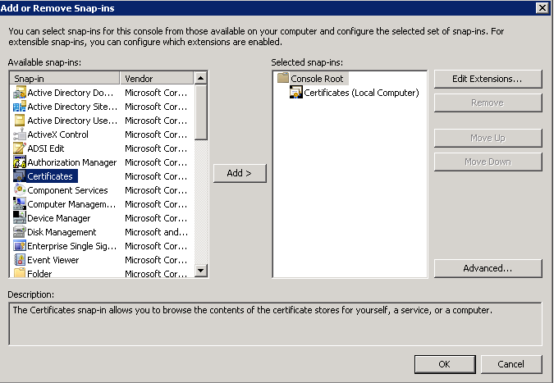
  - Expand Personal folder – Right click on Certificates – All Tasks – Import…

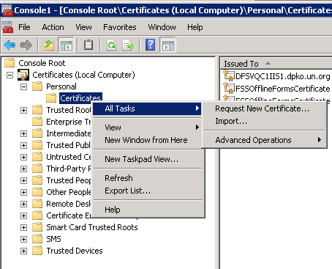
  - Browse the folder in the FSS IIS server where the code certificate was copied.
Note: Select *.pfx as file type
  - Introduce the password. (12345678)
  - Click Next – Next and Finish

- Assign the permissions for the FSS Application Pool to read the certificate
  - Right click on the newly imported certificate UN – All Tasks – Manage Private Keys and add the FSS Application Pool Identity Account.
Note: It is possible to check in IIS Manager – Application Pools – Identity field of the CCMS application pool. In case there is no service account running the Applical, add the local account IIS AppPool\[NameAppPOOL]

- Edit web.config and update the following entry to the new thumbprint of certificate:
<add key="OF_FSS_Code_Signing_Certificate_Thumbnail" value="‎5d850417cbac11323b919a87fd8d63dce118125b"/>

- Restart IIS service

Now the backup of the FSS site folder provided by Legato Team, can be restored in D://site/CCMS

Post Server Configuration and Application Installation

Verify the availability of the application

- Go to https://fss.dfs.un.org.
- Provide your credentials to authenticate. (UNSBV, UNLB or Unite ID)
- Review that the web application correctly loads.

Verify the databases and database services

- Logon on the active back-end server.
- Verify the database and database services.
- Review that the Always-On Availability Group Dashboard is fully green.

3.3 Verify the application processes are working

After the installation of reinstallation, you will need to check that the SQL Jobs are correctly working. Execute and review the outcome of a couple of them.
If a failure occurs, review the log file, usually it will indicate that a step in the procedure to install and configure the server has not been executed.

